North Queensland Games – Lawn Bowls

Yungaburra Bowls Club Inc.  April 2016

The club is located in Cedar Street Yungaburra a 75 minute drive from Cairns via the picturesque Gillies Range Highway.

The club has a full sized synthetic green installed in 2008 which has proved a reliable & true surface to play on.

[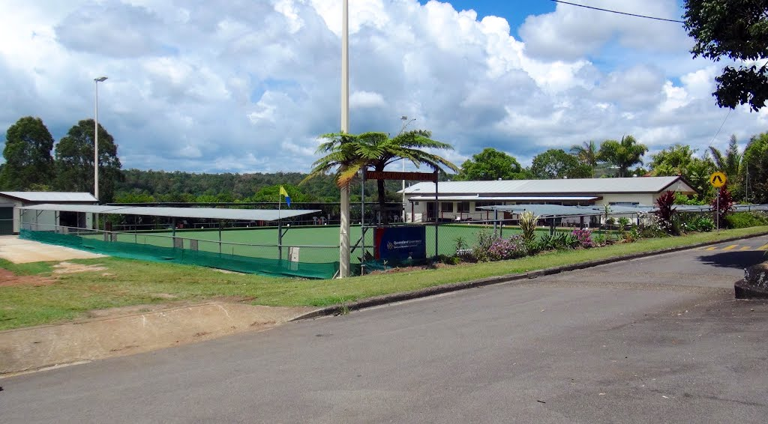](https://www.google.com.au/url?sa=i&rct=j&q=&esrc=s&source=images&cd=&cad=rja&uact=8&ved=0ahUKEwjQ24TA64_MAhXMNpQKHclUAosQjRwIBw&url=http://www.panoramio.com/photo/99777123&psig=AFQjCNH3voT_y5q-jvRzp3xW-h9PA_D4tA&ust=1460782047167991)

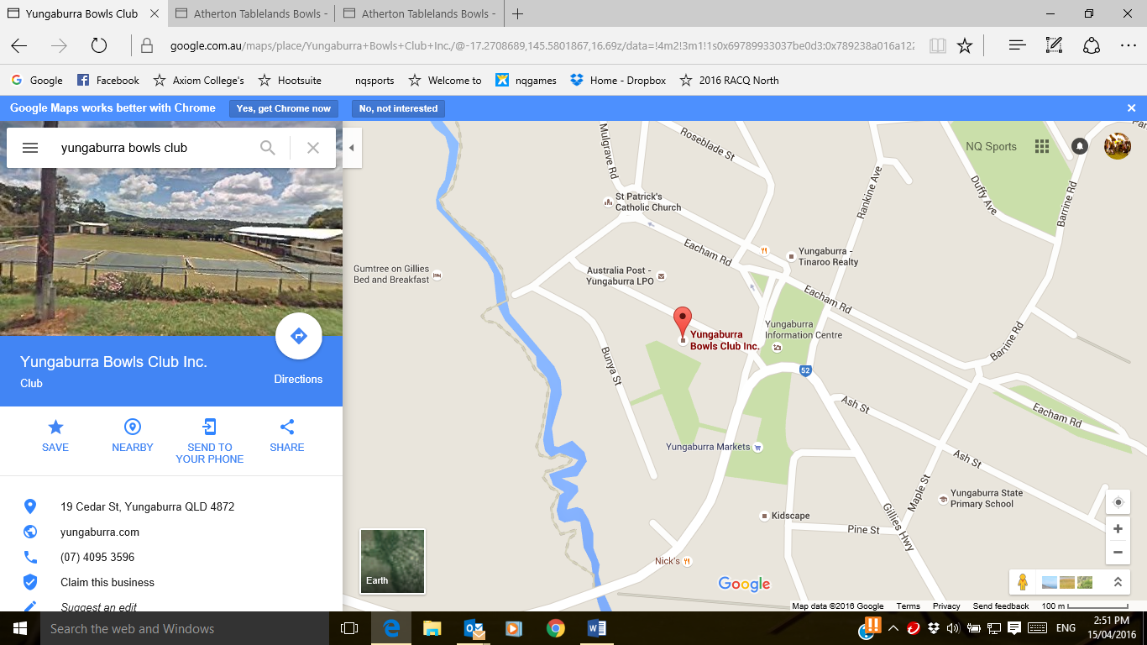

<http://www.athertontablelandsbowls.com/yungaburra-bowls-club>

Proposed competition details:

Date 25-26 June 2016 9.30am start

Open Triples (Men’s, Ladies or Mixed)

5 Games of 15 ends (3 Sat, 2 Sun)

Cost:  $80 per player (Game Fees incl meals $60, NQ Games Entry Fee $20)

Prizemoney: 1st $600, 2nd $300, 3rd $150 plus medals (subject to nominations)

Contact

Gavin Johnson

Chair, Yungaburra Bowls Club Inc

Junior Liaison, TFNQDBA

Tel: 4091 2351 Mob: 0428 275 798

[gavjohnson@aapt.net.au](mailto:gavjohnson@aapt.net.au)